Web Dev I Lab Assignment 3
Responsive Personal Portfolio Website (CSS Advanced)
Problem Statement
Design and build a one-page responsive portfolio website that incorporates Flexbox, CSS Grid, media queries, and animations to create a polished and interactive layout. Use Flexbox to manage alignment and spacing efficiently, and apply CSS Grid to structure at least one section of the page. Implement media queries for a mobile-first design, ensuring the layout adapts seamlessly to desktop, tablet, and mobile screens. Use relative units like rem, em, %, vw, and vh for consistent spacing and font sizing. Enhance interactivity by adding hover effects to navigation links and buttons, smoothing them with CSS transitions, and including at least one keyframe animation along with transition or transform effects on interactive elements.

Objective:
Design and build a one-page responsive portfolio website using Flexbox, Grid, media queries, and CSS animations for a polished and interactive layout.

Learning Outcomes
Upon completion of this assignment, the student will be able to:
- Understand and apply Flexbox for alignment, spacing, and layout control.
- Learn to implement CSS Grid for structured section layouts.
- Develop skills in creating responsive designs using media queries for desktop, tablet, and mobile screens.
- Gain experience with relative units (rem, em, %, vw, vh) for scalable spacing and fonts.
- Apply hover effects and CSS transitions to enhance user interaction.
- Use keyframe animations to make elements visually engaging.
- Implement CSS transforms for interactive elements like buttons or cards.
- Improve visual hierarchy and design consistency through spacing, alignment, and typography.
- Learn to combine multiple CSS techniques (Flexbox, Grid, transitions, animations) in a single project.
- Build a polished, professional-looking portfolio that is both functional and responsive across devices.

Detailed Instructions

1) Structure & Sections
Organize your portfolio into clear parts: Header, Hero, About, Skills, Projects, Contact, and Footer. This helps in keeping the website clean and easy to navigate.
2) Flexbox Layout
Use Flexbox for arranging elements in the header (logo and navigation links) and in the hero section (intro text on the left, profile image on the right). It ensures proper alignment and spacing.
3) Grid Layout
Apply CSS Grid for displaying skills and projects. Each skill or project should be in a card, arranged neatly in rows and columns for a modern look.
4) Responsive Design
Make sure the website looks good on mobile, tablet, and desktop. Use media queries so that layouts adjust, like stacking hero text and image on small screens.
5) CSS Units
Use flexible units like %, rem, and vw/vh instead of fixed pixels. This makes your design scale better across different devices and screen sizes.
6) Typography
Choose a clean, modern font (like Google Fonts). Maintain hierarchy with big headings, medium subheadings, and readable body text for clarity.
7) Color Theme
Pick 2–3 main colors for consistency. Highlight important text like “Full Stack Developer” with a color-changing animation to grab attention.
8) Hover Effects
Add hover effects to buttons, links, and cards. Use smooth transitions so that interactions feel modern and engaging for the user.
9) Animations
Use simple animations like fade-in or slide-in when sections load. The hero text or headings can have a color-changing effect for more visual appeal.
10) Contact & Footer
Create a simple contact form with name, email, and message fields. Design the footer with copyright info and links to social media or quick navigation.

Expected Output

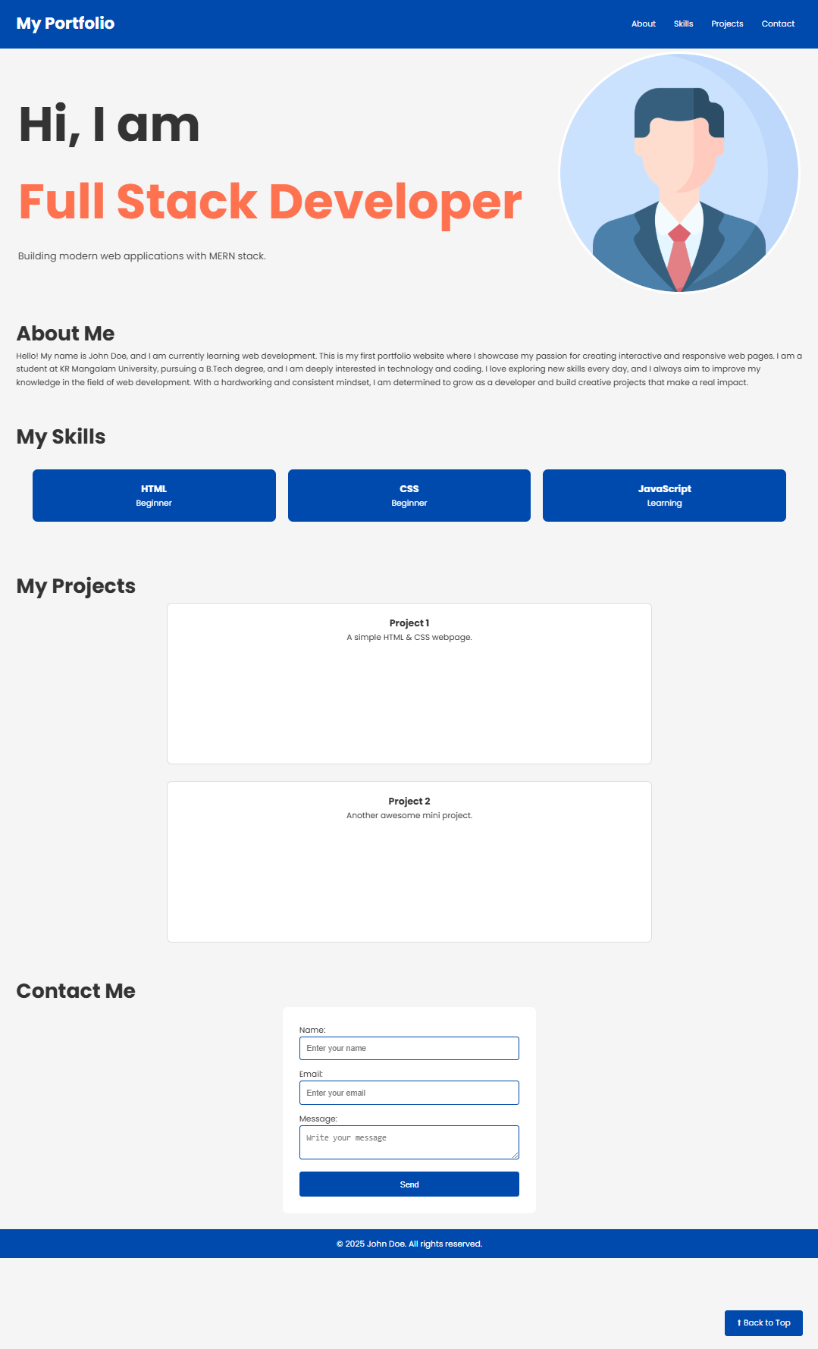

Guidelines to Students
- Build on Lab 2 – Use your existing Lab 2 project as the base and enhance it with modern CSS features like Flexbox, Grid, animations, and responsive design.
- Maintain Proper Structure – Organize your website into clear sections (Header, Hero, About, Skills, Projects, Contact, Footer) for easy navigation and readability.
- Focus on Design & Responsiveness – Ensure your website looks good on desktop, tablet, and mobile. Use media queries and flexible CSS units for smooth scaling.
- Apply Styling & Effects – Use a consistent color theme, readable fonts, hover effects, and simple animations (like color change or fade-in) to make the site attractive.
- Keep Code Clean – Write neat, well-structured HTML and CSS with proper indentation and comments for clarity and future updates.
- Finalize & Submit – Test your website on different devices/browsers, make corrections if needed, and submit the project on time with all required files.

Improvements / Adjustments
- Hero Section Enhancement – Add animated text (e.g., “Full Stack Developer” color-changing effect) and place profile image on the right side with proper alignment
- Layout Upgrade – Replace basic CSS positioning with Flexbox and Grid to properly arrange sections, making the design modern and professional.
- Responsive Adjustments – Ensure content reflows properly on small screens (text above image in hero, grid items stacking in one column).
- Design Consistency – Improve color theme, use proper font hierarchy, and maintain equal spacing/margins for a neat, balanced look.
- Interactive Elements – Add hover effects on buttons, links, and project cards, along with smooth transitions for better user experience.
- Content Expansion – Update About, Skills, and Projects sections with more details (e.g., extra skills, sample project cards, short descriptions).

Submission Guidelines
- Push updated HTML and CSS files to a GitHub repository.
- Include a README.md with:
  - Lab title and description
  - Steps to view responsive behavior (mention breakpoints tested)
- Share the GitHub repository link with the concerned faculty.

Performance Metrics (Out of 5 Marks)

Criterion | Marks
Flexbox & Grid Usage | 1
Responsive Design | 1
Relative Units | 1
Animations & Effects | 1
Code Quality | 1

